First and Last Name, 6/7C
Language Arts – Literary Devices
Due: October 25, 2019

FELINES OF FREDERICTON
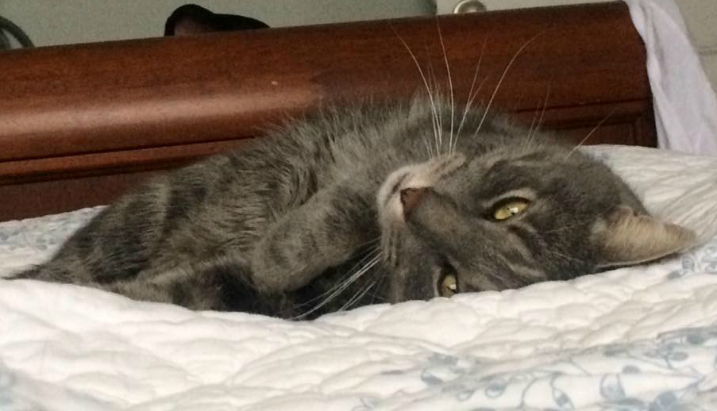
I have been living with my family for almost three years. I'm what you'd call an indoor cat. I love to get treats, sun myself by the window and take long naps at the foot of the bed. My favourite thing to do is sit in cardboard boxes.
Simile- A comparison using the words “as” or “like.”
When I'm not taking one of my famous naps, I can be as playful as a kitten. But one day, this was not the case. As much as my boy tried to get me to chase after the toy mouse, I just simply looked on, completely indifferent.
Hyperbole-to exaggerate statements or claims not meant to be taken literally.
We had played this game a million times, and each time, I had chased after the mouse relentlessly.
Alliteration-is the occurrence of the same letter or sound at the beginning of adjacent or closely connected words.
Had I forgotten how to chase the toy mouse? Could my memory have gone to mush? I asked myself.
Metaphor- A comparison without using the words “as” or “like."”
This time, I sat there quietly, without any expression on my face whatsoever. My boy couldn't help but ask - "Cat got your tongue, Miyoki?", as he choked back his laughter.
Personification-when an author gives something nonhuman, person-like characteristics.
My eyes were dancing with mischief, as I looked at my boy as if to say, “I won’t chase this toy every time because I don’t want to set some sort of expectation. I don’t need you believing that I will actually do something if a real mouse makes it inside.”
Onomatopoeia- is the formation of a word from a sound associated with what is named.
Then suddenly, without even a murmur, I just got up and walked away. It was at that moment that I was reminded of something that I once heard....."As every cat owner knows, nobody owns a cat, but I must say... this cat owns his human".

